Name : Pragati Ghorpade
PRN : 202501050030
Course : EDS

Practical 2
1)
Program :
l1 =[]
while True:
print("1. Add")
print("2. Remove")
print("3. Display")
print("4. Quit")
n = int(input("Enter choice: "))
if n == 1:
add = int(input("Integer: "))
l1.append(add)
print(f"List after adding: {l1}")
elif n == 2:
if len(l1) == 0:
print("List is empty")
elif len(l1) != 0:
remove=int(input("Integer: "))
if remove not in l1 :
print("Element not found")
else:
l1.remove(remove)
print(f"List after removing: {l1}")
elif n == 3:
if len(l1) == 0:
print("List is empty")
else:
print(l1)
elif n == 4:
break
else:
print("Invalid choice")
Output :
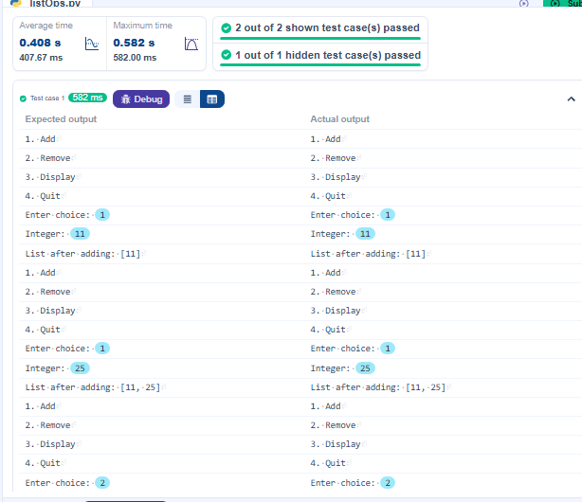

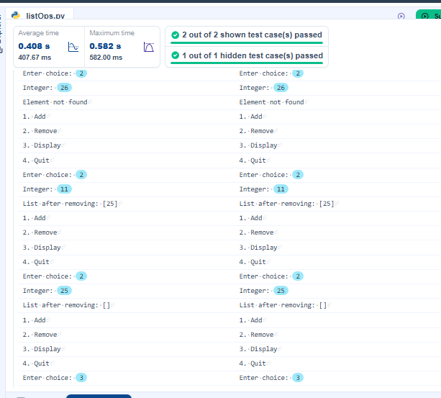

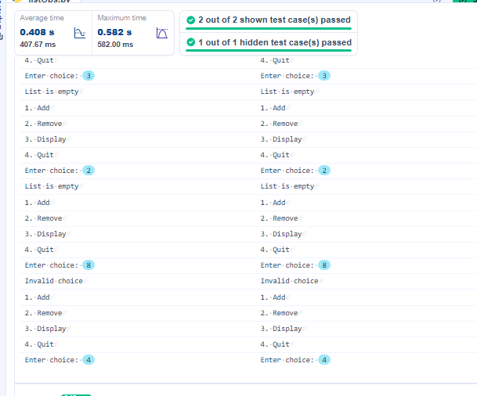

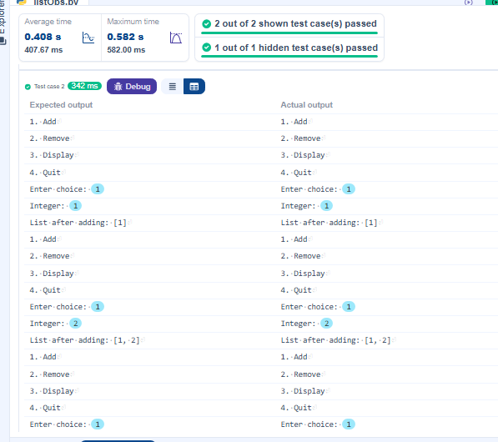
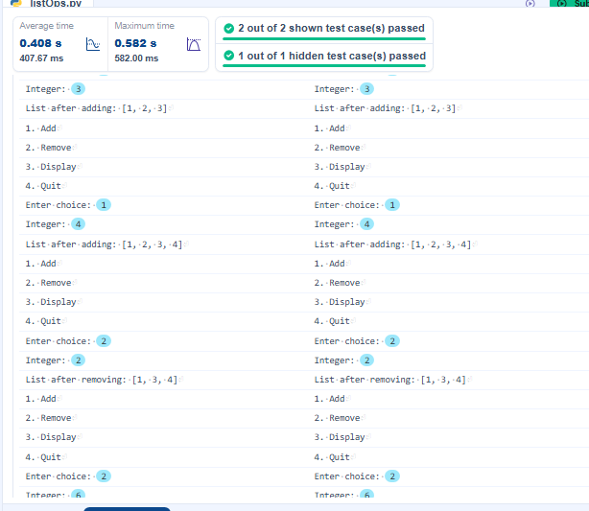

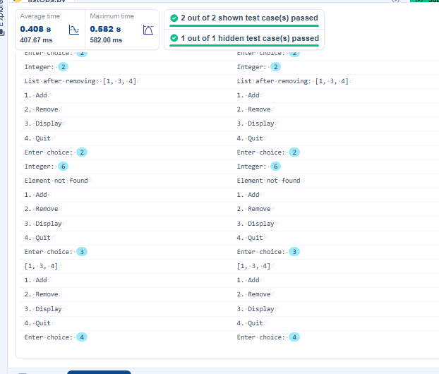

2)
Program :
# Initial dictionary with 10 predefined records
student = {
1: "Amit",
2: "Riya",
3: "Kiran",
4: "Neha",
5: "Arjun",
6: "Pooja",
7: "Rahul",
8: "Sneha",
9: "Vikram",
10: "Anjali"
}

# write your code here...
print("Original Dictionary:",student)
key1= int(input())
value1=input()
student.update({key1:value1})
print("After Insertion:",student)

key2=int(input())
value2=input()
if (key2 in student.keys()):
student.update({key2:value2})
print("After Update:",student)

key3=int(input())
if (key3 in student.keys()):
student.pop(key3)
print("After Deletion:",student)

print("Traversing Dictionary:")
for key,value in student.items():
print(f"{key} : {value}")

Output :
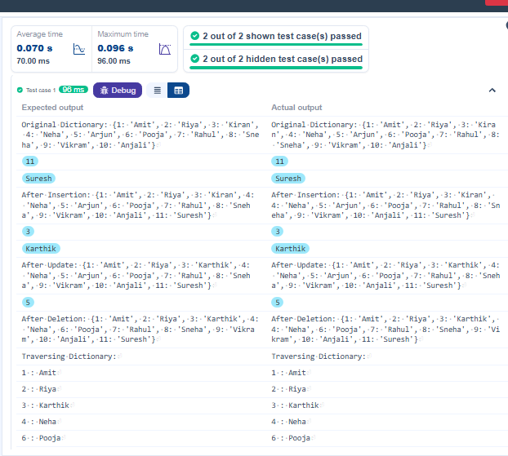
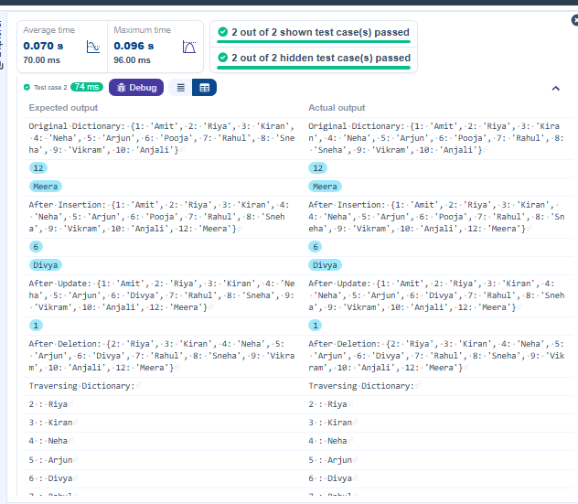

3)
Program :
def linear_search(arr, key):
for i in range(len(arr)):
if arr[i] == key:
return i
return -1
arr = list(map(int, input().split()))
key = int(input())
result = linear_search(arr, key)
if result != -1:
print(result)
else:
print("Not found")
Output :
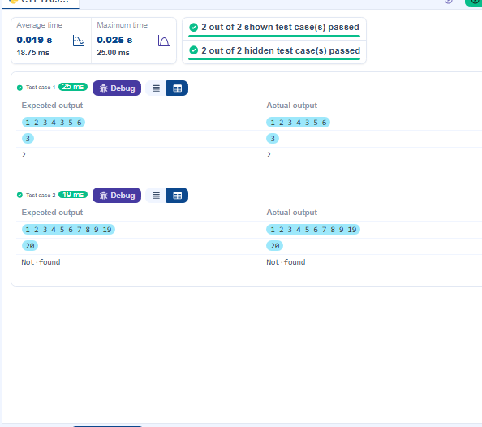

4)
Program :
heights = list(map(int, input().split()))
tallest_player = max(heights)
print(tallest_player)

Output :
